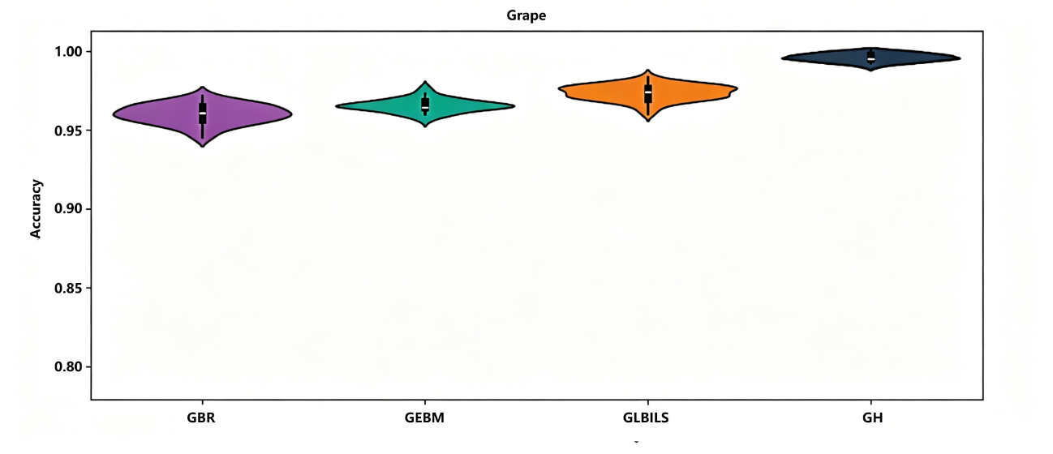
Figure 4.9 Violin Plot of Grape Disease Identification Accuracy

